**ASSIGNMENTS ON DIGITAL MARKETING**

**NAME:** ALSUBAIR.A

**DEPARTMENT:** BE BIOMEDICAL ENGINEERING

**COLLEGE:** 8151 DHANALAKSHMI SRINIVASAN INSTITUTE OF

TECHNOLOGY

**NAANMUDHALVAN COURSE**: DIGITAL MARKETING

**NM ID:** 8D3A0D48C54D634BD72445365AACAE2

**ASSIGNMENT 1:**

Create a blog or website using Blogspot and WordPress. Customize

The theme design and post new article with 500 words.

<https://ta834.wordpress.com/2023/10/18/tahfix-tech/>

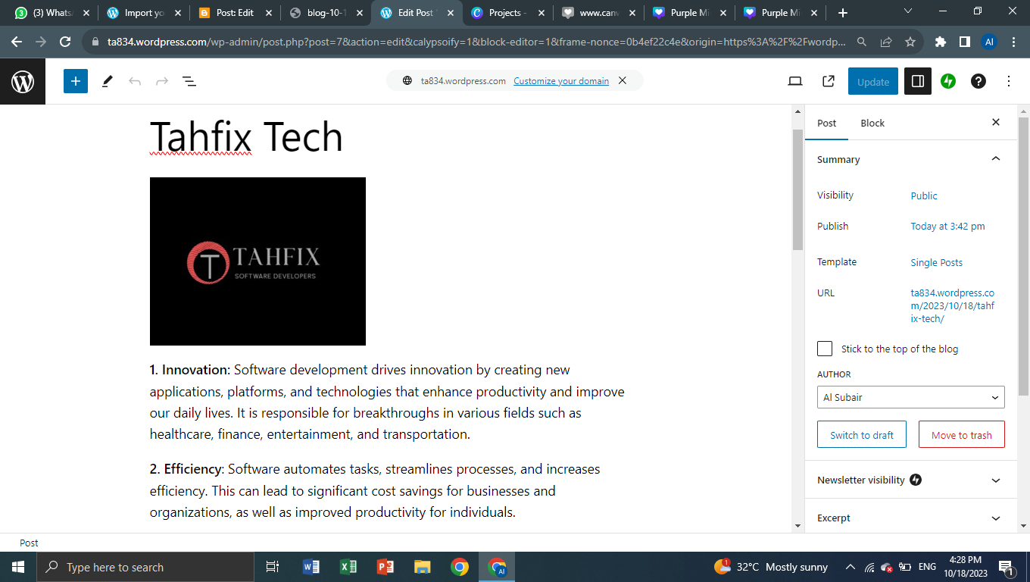

**ASSIGNMENT 2:**

Create a new Facebook business Page and Post one social media poster for your brand.

<https://www.facebook.com/profile.php?id=61550803269548>

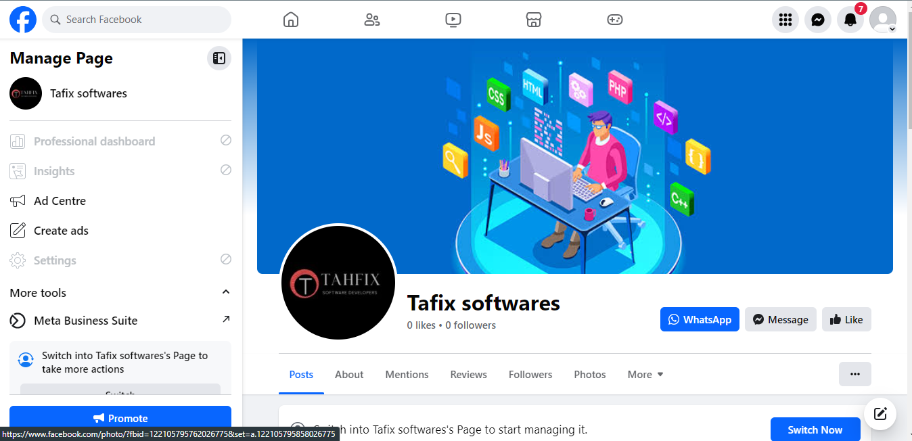

**ASSIGNMENT 3:**

Create and design a social media advertisement poster using Canva.

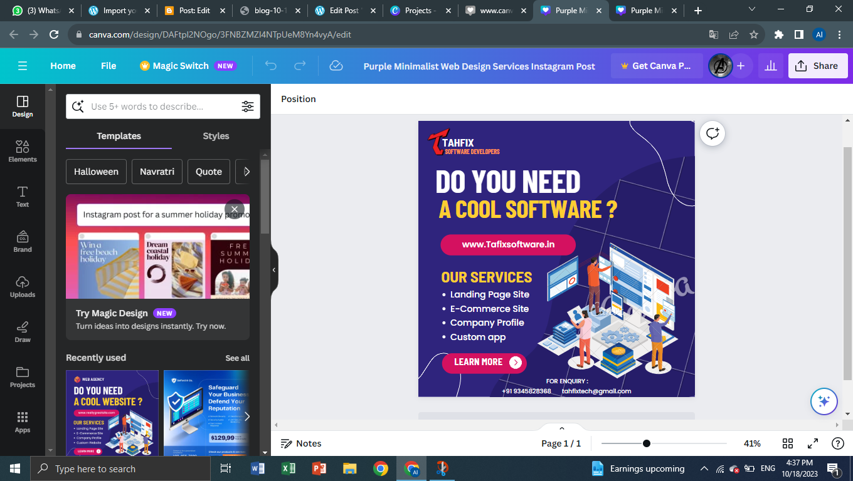

**ASSIGNMENT** 4.Create email newsletter design usingMailChimp or Canva tool

